**CREATION OF RDS AND DMS**

**Relational Database Service:**

**Connect to a Database:**

Open the AWS RDS console, in the left corner you will see the query editor. click on the query editor now you will see connect to database page.

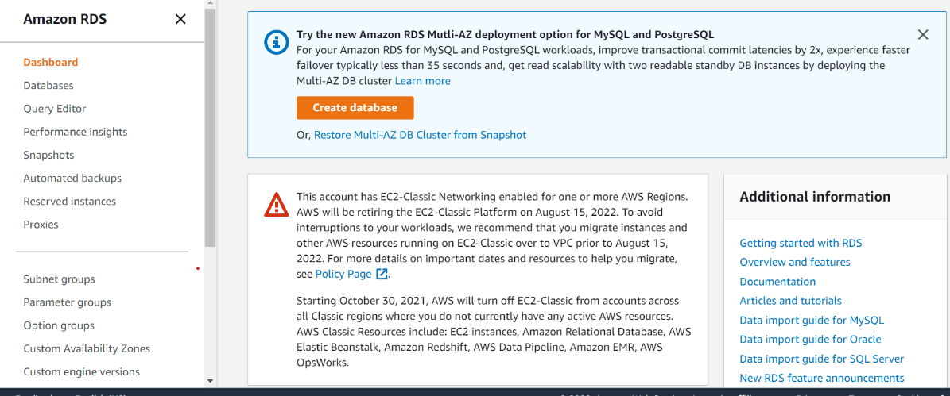

Enter the database name that we created in place of database instance and also give the required credentials to connect to a database.

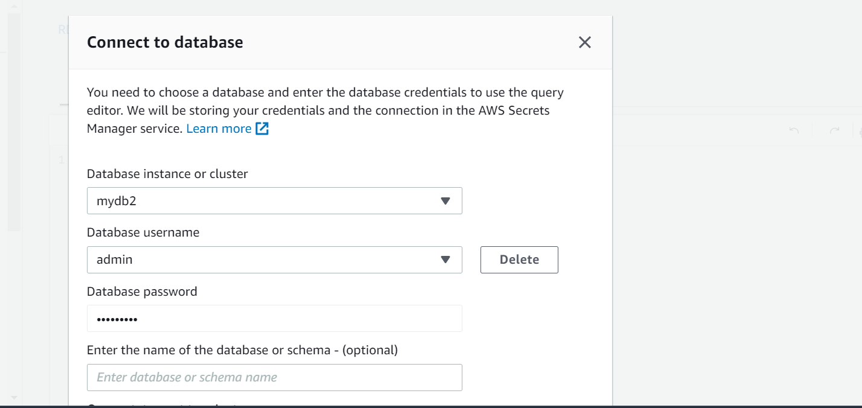

**Creating a Database:**

Now create the database to store the data using query editor.

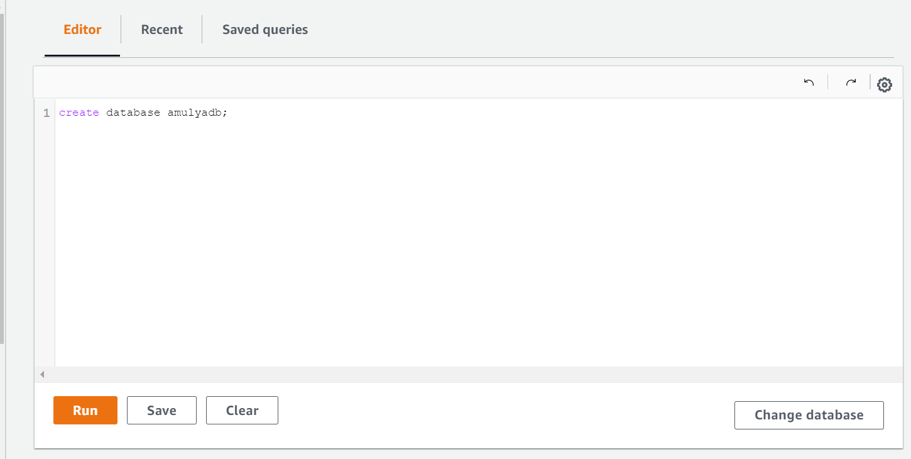

**Creating a Table:**

After creating the database, we need to create the table using database name.

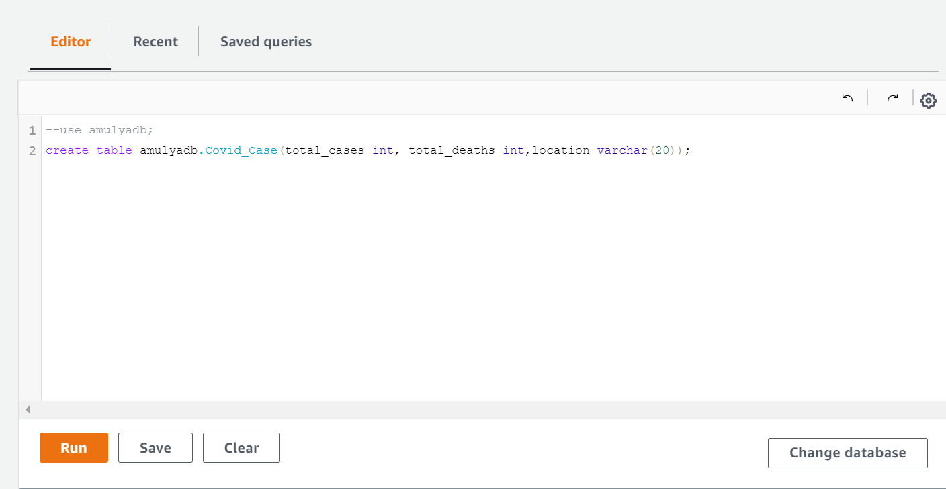

**Inserting values a Table:**

Insert the values into the table using database. We will get the error if we are not using the database name.

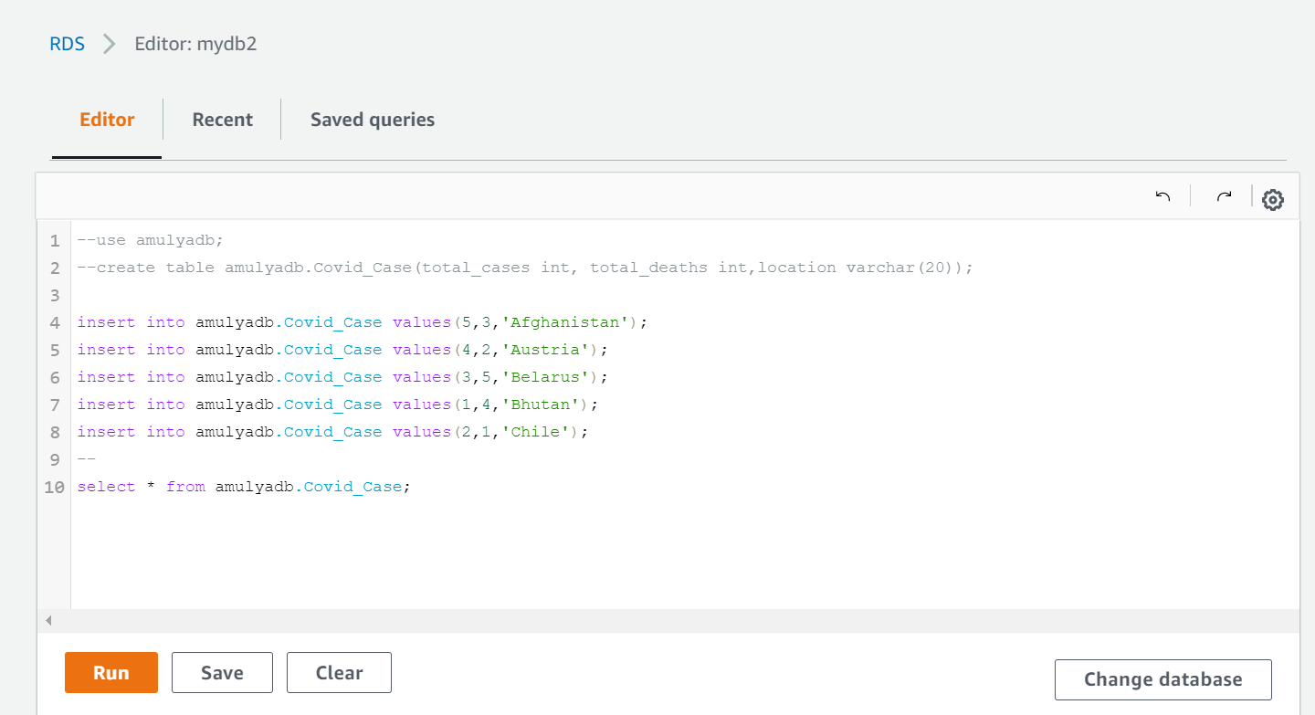

**Result:**

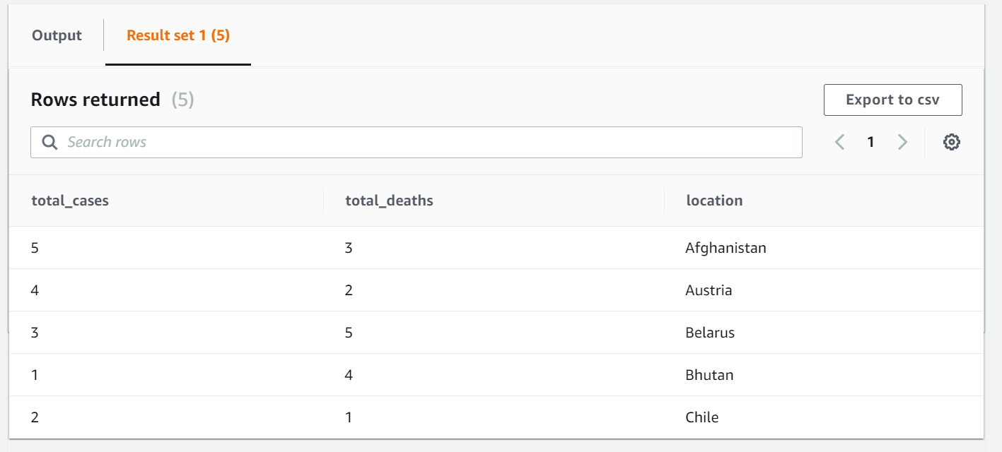

**Database Migration Service:**

**Creating** [**Replication instances**](https://us-west-2.console.aws.amazon.com/dms/v2/home?region=us-west-2#/replicationInstances)**:**

Open the DMS console in the AWS. Select the create replication instance on the right side corner of the console.

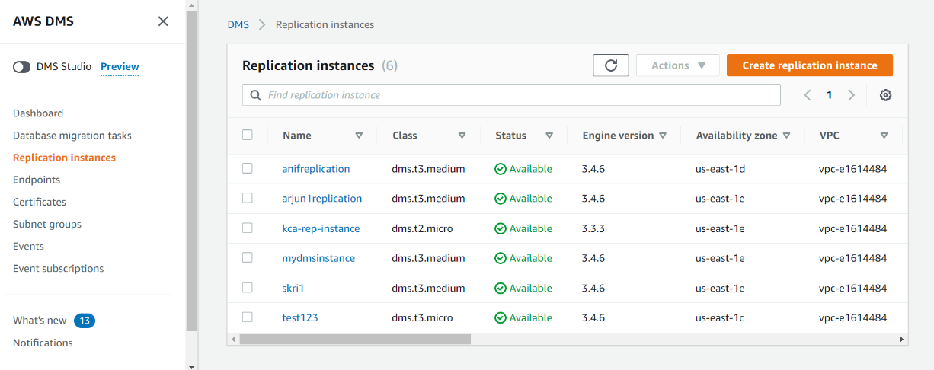

**Replica Instance Configuration:**

Enter the required details in the name, vpc, multi Az and create the replication instance.

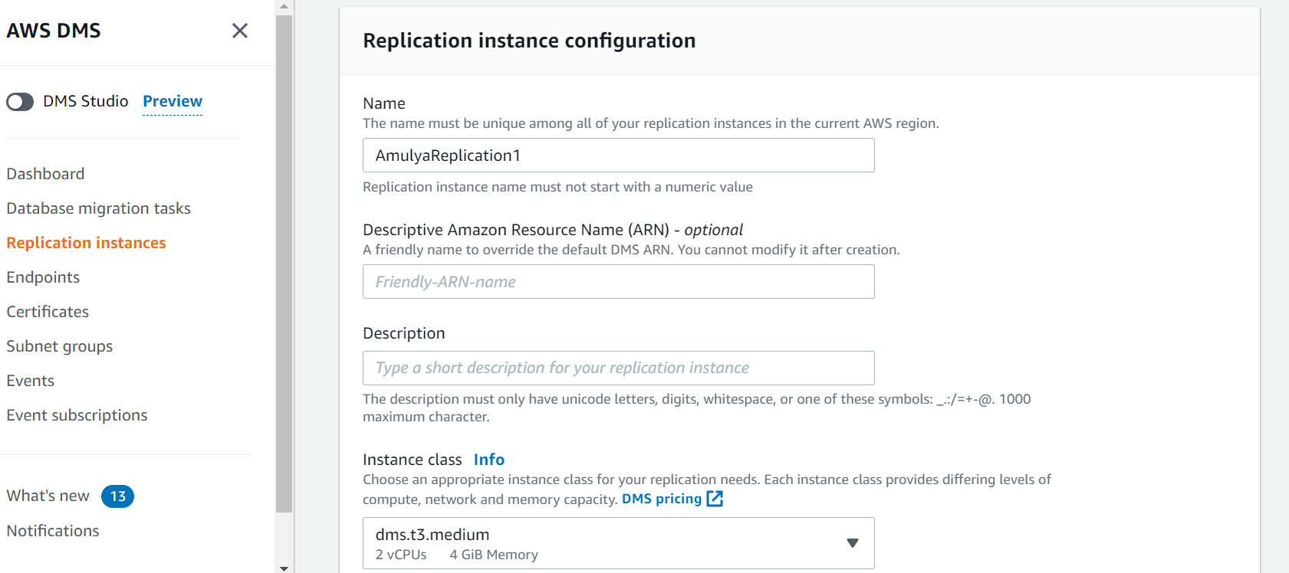

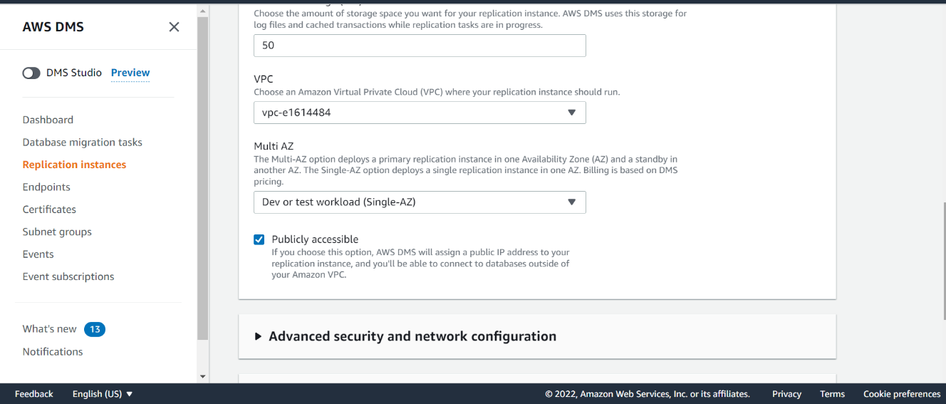

**Successfully Created Replication Instance:**

Now you will see the created replication instance in the DMS console.

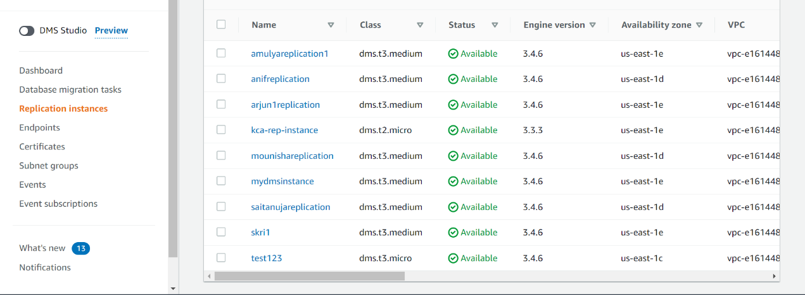

**Endpoint Creation for Source:**

Open the endpoint to create the endpoint source.

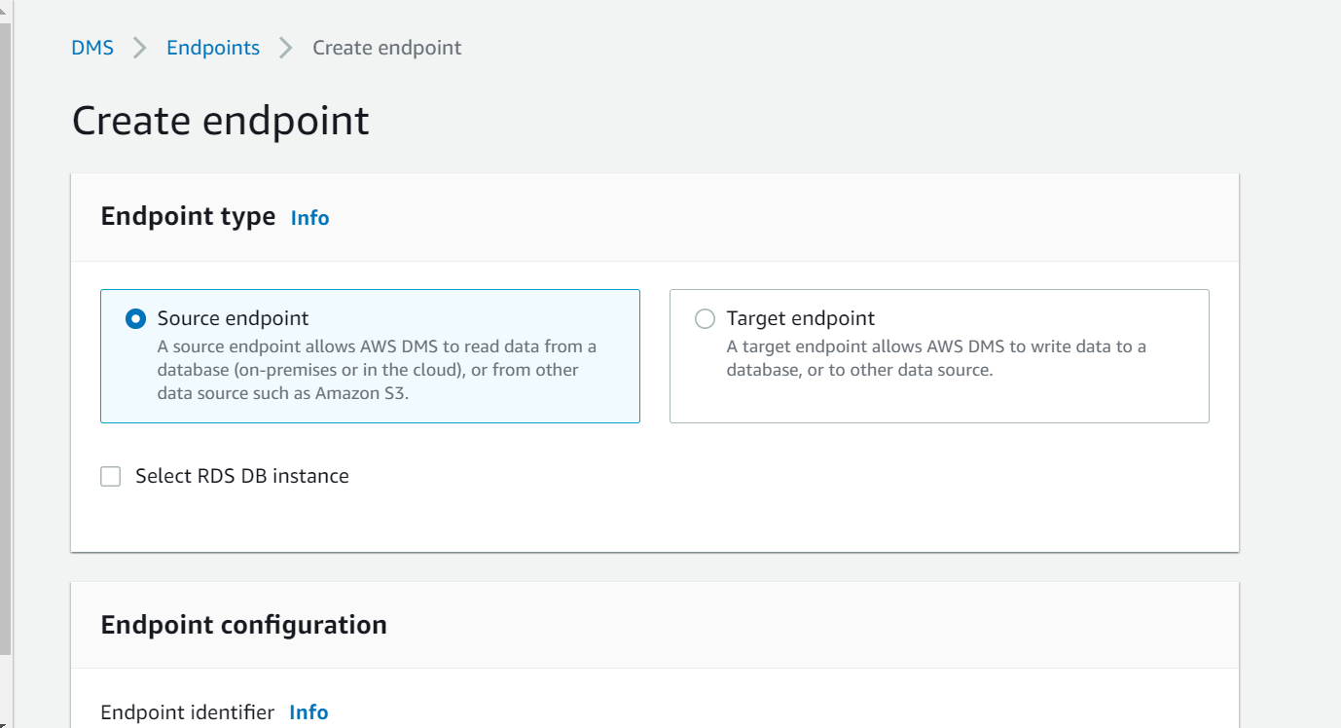

**From RDS select the required details:**

In order to create the endpoint in DMS, we need to get the details from RDS.

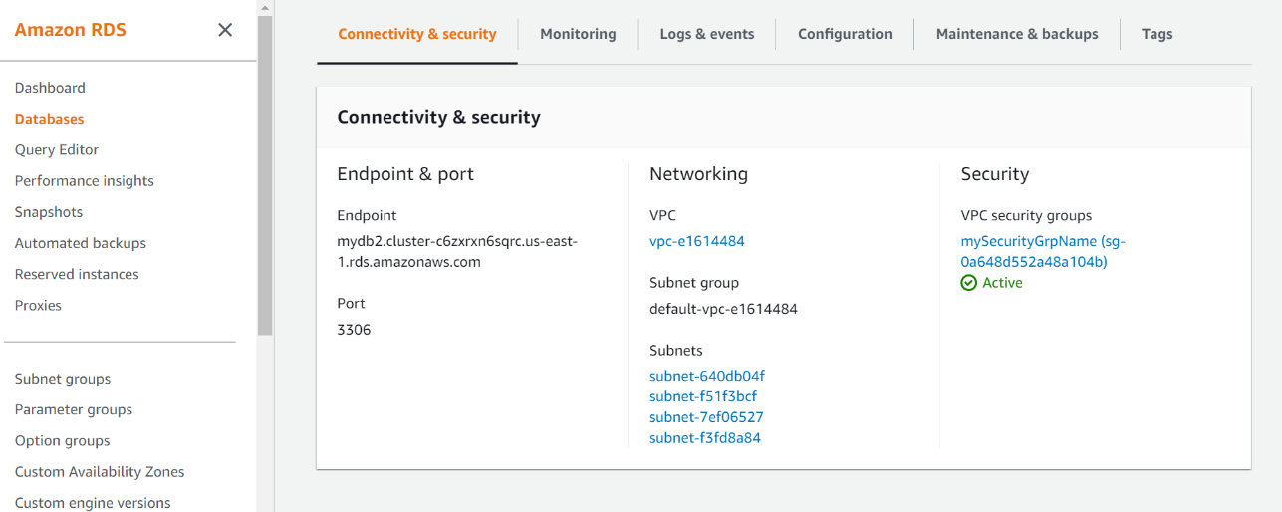

**Enter the selected details in required columns:**

Select the endpoint server address, port address, admin address and password from the RDS and enter in the endpoint details in the DMS.

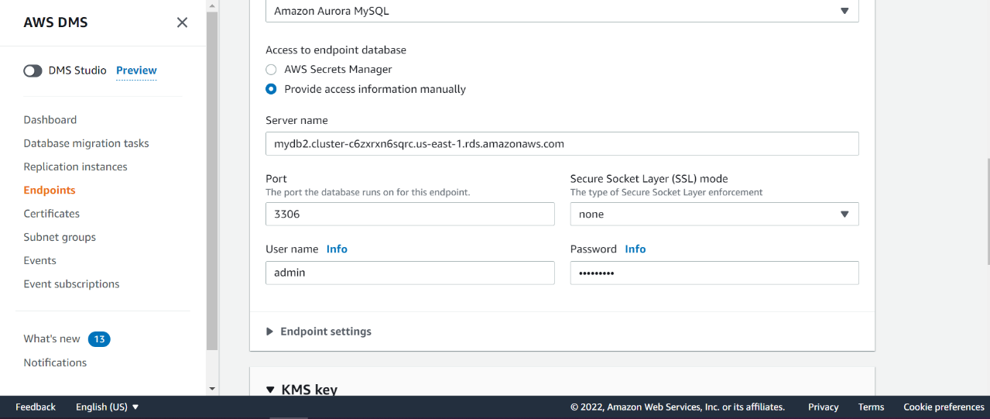

Once endpoint creation is done you will see the endpoint name in the list as an active state.

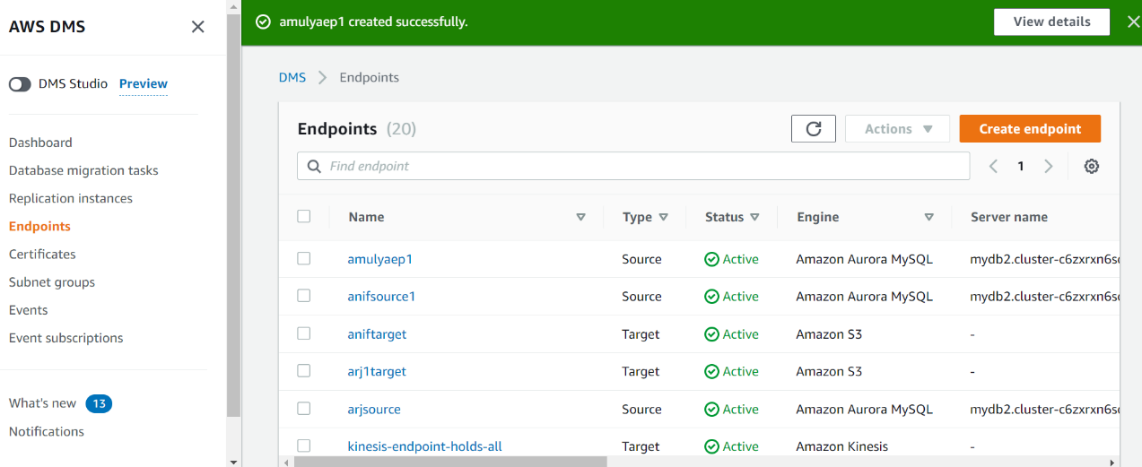

**Creating Endpoint for Target:**

To create the endpoint target you need to select the target endpoint in the create endpoint page.

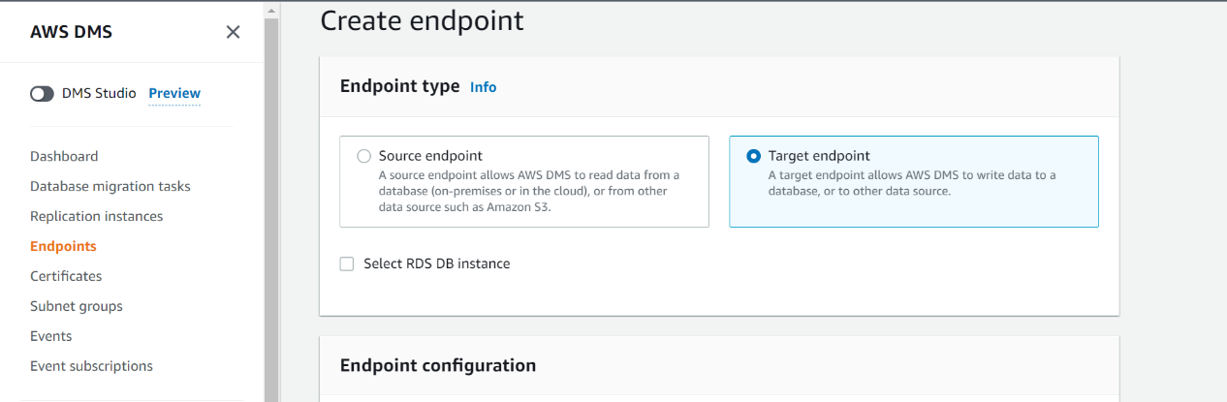

**Endpoint Configuration for Target:**

In endpoint configuration give the name in endpoint identifier and give the target engine as amazon s3,enter the RDS service address as service access role ARN.

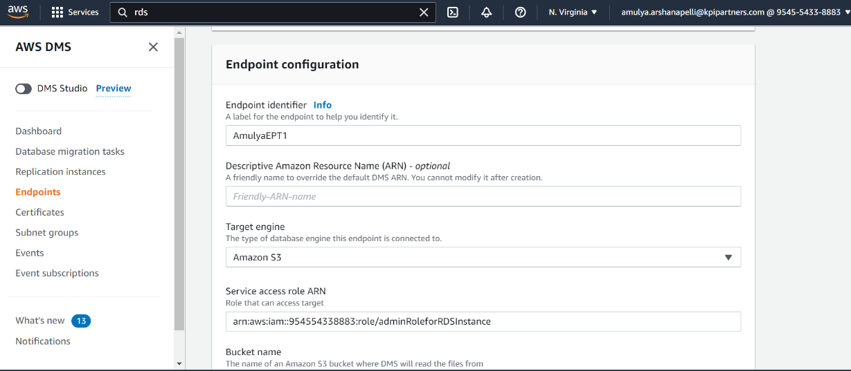

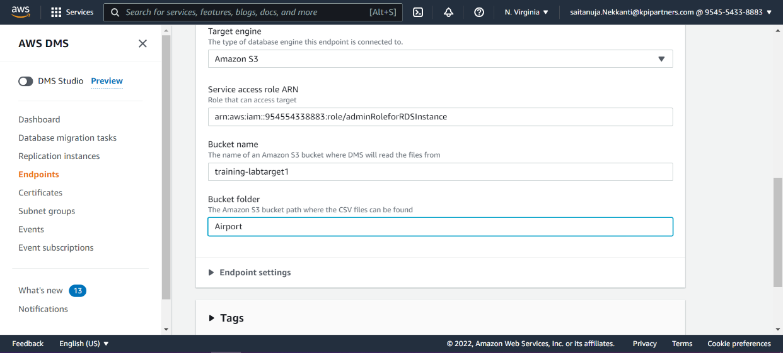

**Successfully Created Endpoints for Source and Target:**

Once the endpoint is created you will the endpoints in the list as active state.

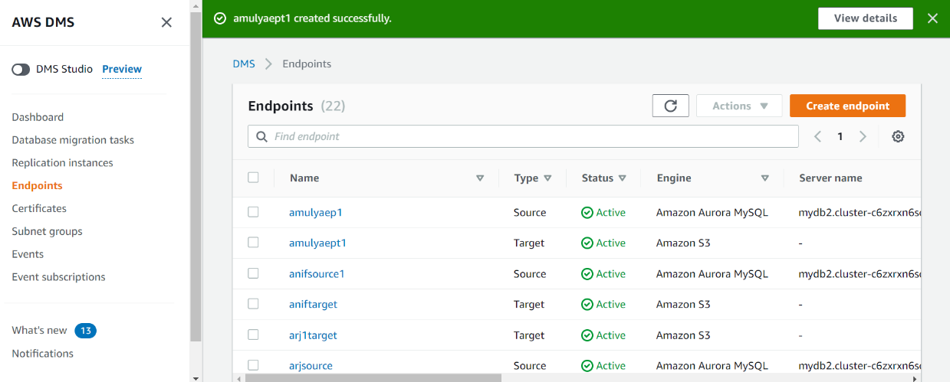

**Creating a Task:**

To create a task in the DMS, select the database migration tasks in the in the left side corner of the DMS AWS console and enter the replication instance as created vpc, source and target database endpoint as created endpoints in the DMS.

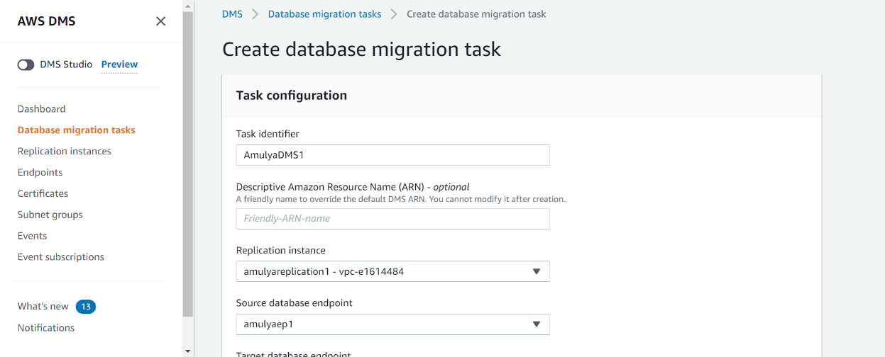

**Task Created Successfully:**

Once the task is created you will see the task in ready state in the tasks list.

